Resources for Spirit of ’45 Events
Support the Campaign!
We don’t have war bonds for sale, but we could certainly use some donations to help support the ongoing campaign to establish a National Spirit of ’45 Day.
Or, you can show your Spirit by purchasing some of the items available here. Please visit our vendors:
- Cake Template & Image
- Flyer Templates & Images
- Robert Tasner & Assoc. – buttons, mugs, and other gear.
- Prisma Banners – banners and photos (parade-style and Wall of Honor)
Thank you for your support!
Cake Template & Image
Picture of The Cake  (jpg format [391 KB] – very large)  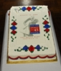 | Template of Kiss for The Cake  (jpg format [524 KB] – very large)  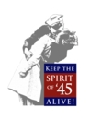
Zip file of both Cake Picture and Kiss Template.
(zip format [699 KB] – very large)

Flyer Templates & Images
These top 3 templates are very large to view in your browser. To save without viewing, right click on the picture and select the Save option in the popup menu. Then choose where on your computer you wish it to be saved and click Ok.
  (pdf format [986 KB] – very large) | 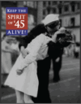  (pdf format [681 KB] – very large) | 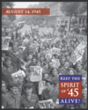  (pdf format [748 KB] – very large)
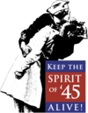  (jpg format [77 KB]) | 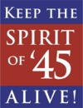  (jpg format [45 KB]) |   (jpg format [47 KB])

Order Spirit buttons, mugs, and other gear.
Show the world how proud you are to support the Spirit of ’45 campaign. | 
Office: (831) 464-1218, Mobile: (831) 334-3306
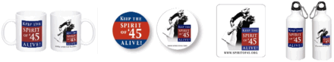

Order banners and parade-style photos
from Prisma Banners.
Click to see the the video (on YouTube) showing you how to submit a photo for the Wall of Honor.
